**Task 1.** Write a query to fetch all users' account names and their number of followers, sorted in descending order by the number of followers.

Query: **select Account_Name,Followers from user_data order by Followers desc;**

Output Screenshot:

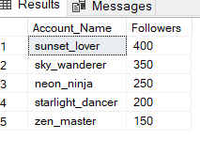

**Task 2.** Write a query to retrieve the account names of all female users who joined before 2020.

Query: **select Account_Name from user_data where Gender='Female' and Date_Joined < '2020-01-01';**

Output Screenshot:

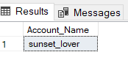

**Task 3.** Write a query to find all users who have more than 100 posts and less than 500 likes.

Query: **select Account_Name,Posts,Likes from user_data where Posts>100 and Likes<500;**

Output Screenshot:

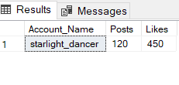

**Task 4.** Write a query to count the number of users who joined after January 1st, 2020.

Query: **select count(*) as User_Count from user_data where Date_Joined>'2020-01-01';**

Output Screenshot:

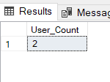

**Task 5.** Write a query to group users by gender and show the total number of likes per gender.

Query: **select Gender,sum(Likes) as Total_Likes from user_data group by Gender**

Output Screenshot:

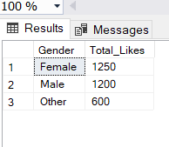

**Task 6.** Write a query to find the total number of posts made by all users combined.

Query: **select sum(Posts) as Total_Posts from user_data**

Output Screenshot:

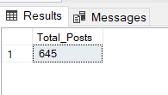

**Task 7.** Write a query to find the average number of likes for users with more than 200 followers.

Query: **SELECT AVG(Likes) AS Avg_Likes FROM user_data WHERE Followers > 200**

**GROUP BY Followers;**

Output Screenshot:

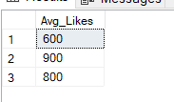

**Task 8.** Write a query to retrieve the account names and likes of the top 3 users with the most likes.

**Query: select top 3 Account_Name,Likes from user_data order by Likes Desc;**

Output Screenshot:

